Lab 12: Enhance a web application by using the Azure Content Delivery Network

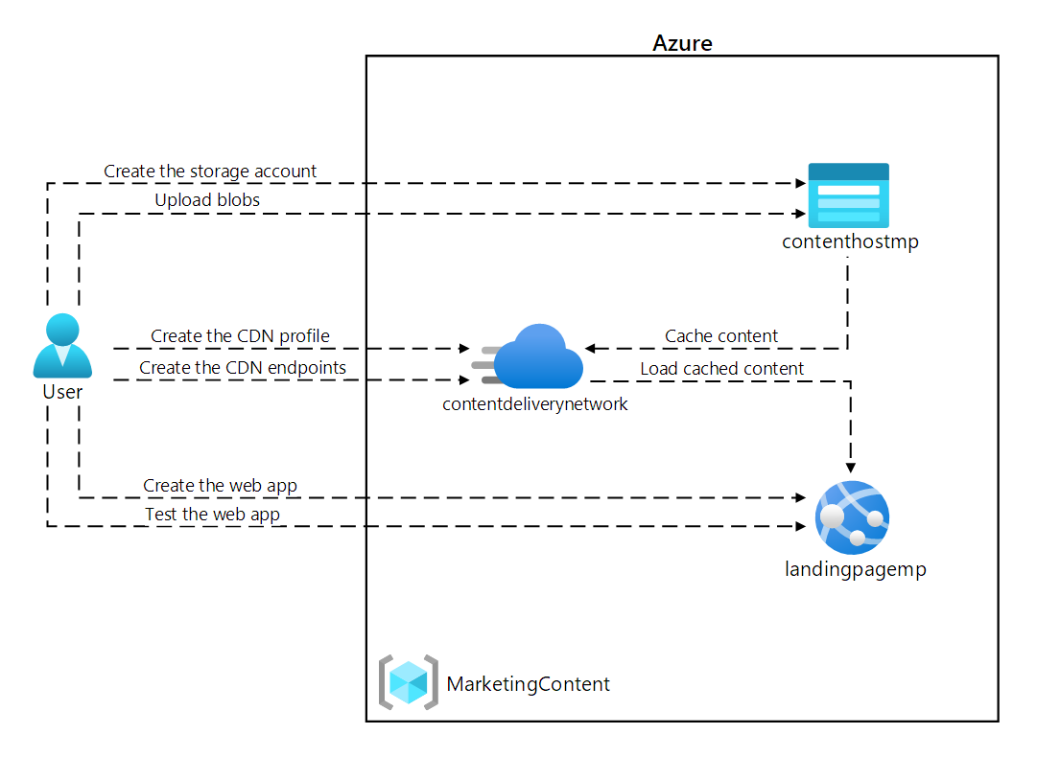

### **Exercise 1: Create Azure resources**

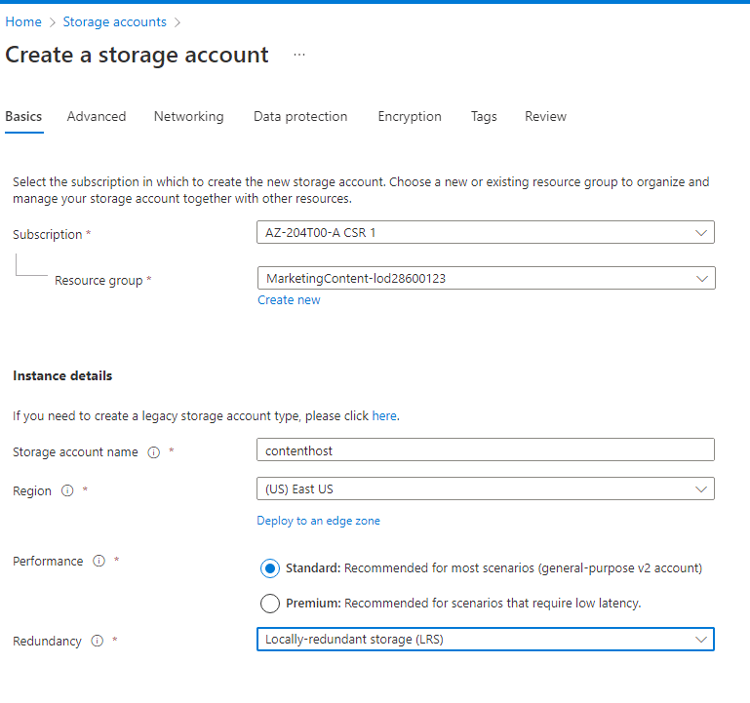

#### **Create a web app by using Azure App Service**

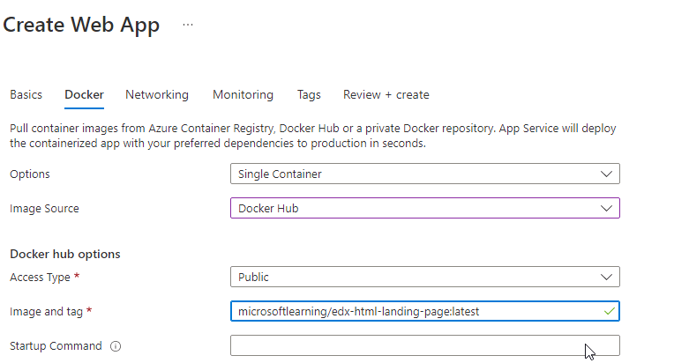

Record url

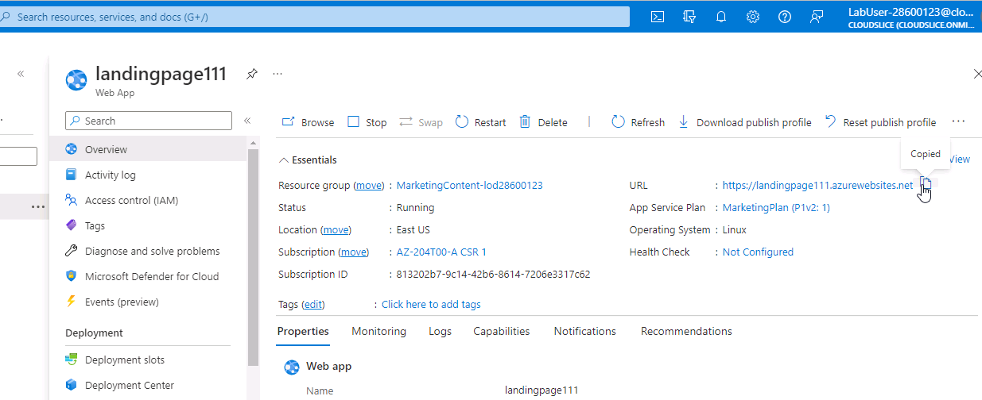

<https://landingpage111.azurewebsites.net>

In this exercise, you created an Azure Storage account and an Azure Web App that you'll use later in this lab.

### **Exercise 2: Configure Content Delivery Network and endpoints**

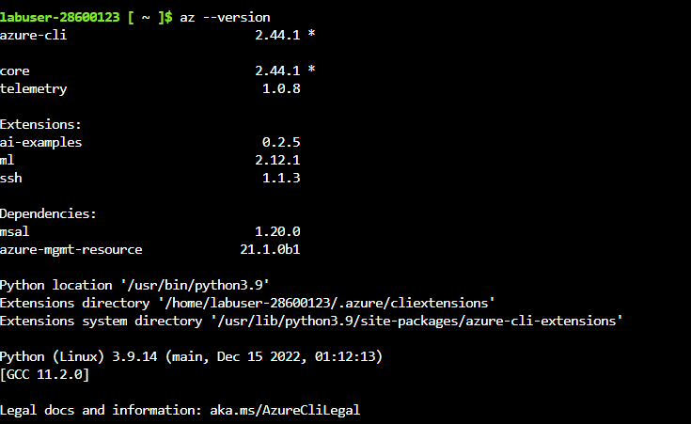

#### **Register the Microsoft.CDN provider**



#### **Create a Content Delivery Network profile**

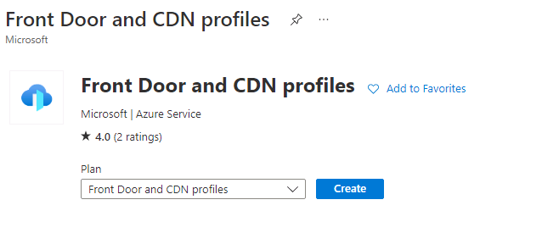

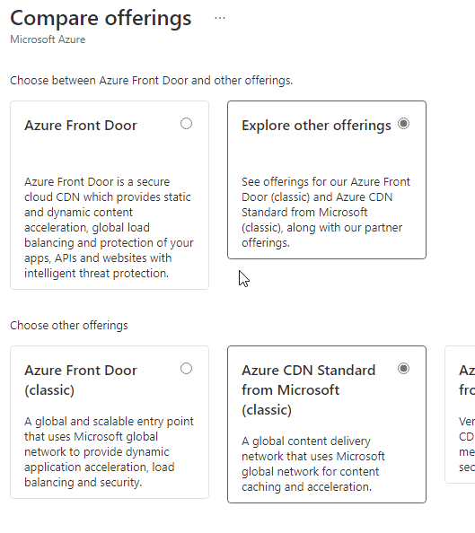

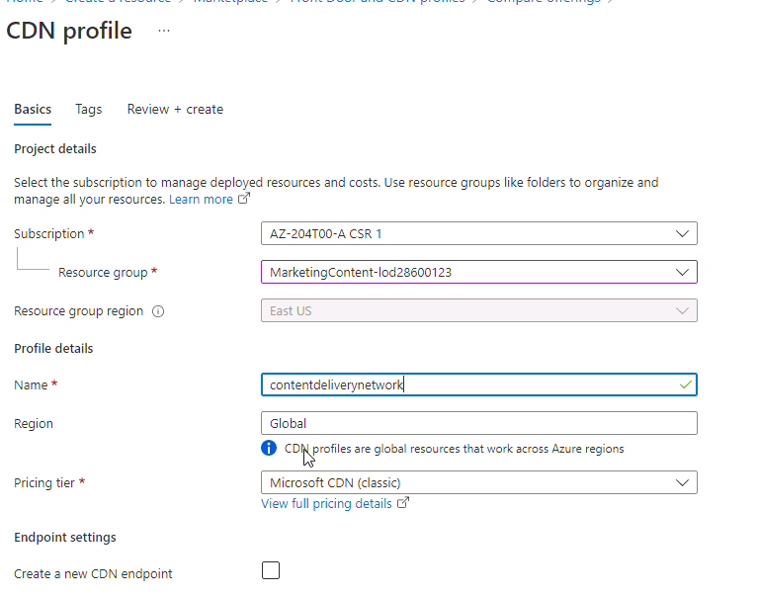

#### **Configure Storage containers**

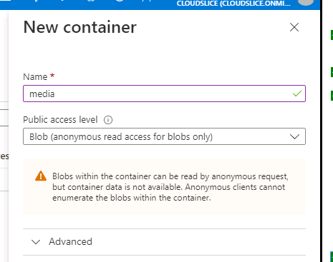

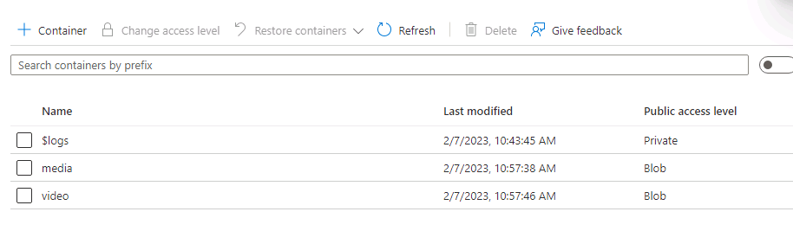

#### **Create Content Delivery Network endpoints**

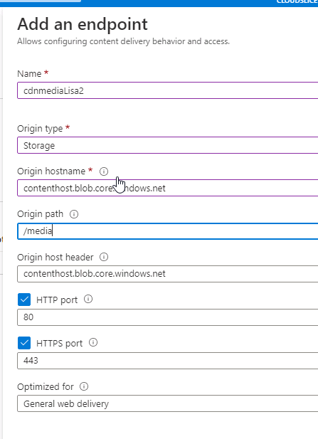

And for video

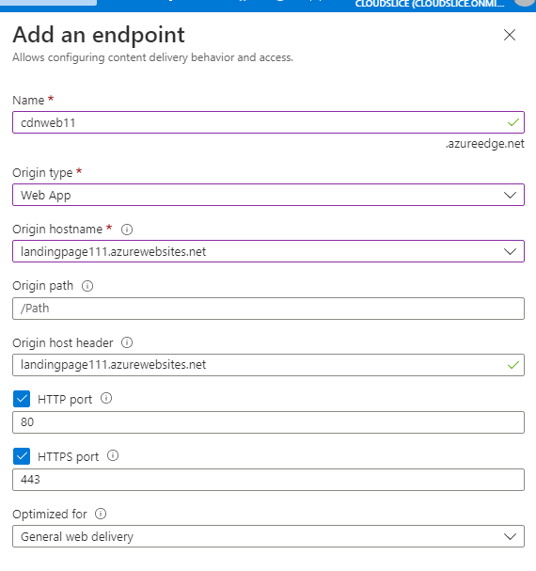

In this exercise, you registered the resource provider for Content Delivery Network (CDN), and then used the provider to create both a CDN profile and endpoint resources.

### **Exercise 3: Upload and configure static web content**

#### **Observe the landing page**

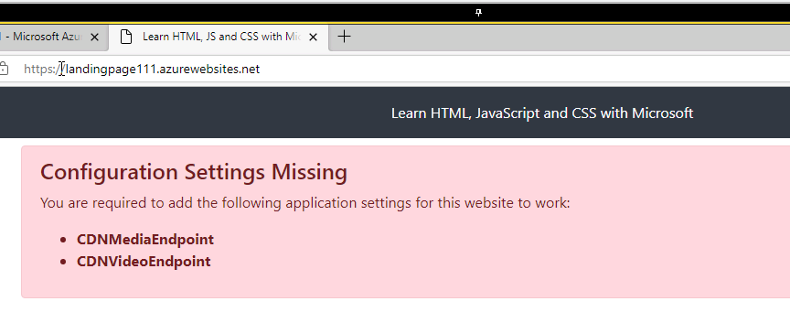

The website won't work until you configure the specified settings to reference multimedia content.

#### **Upload Storage blobs**

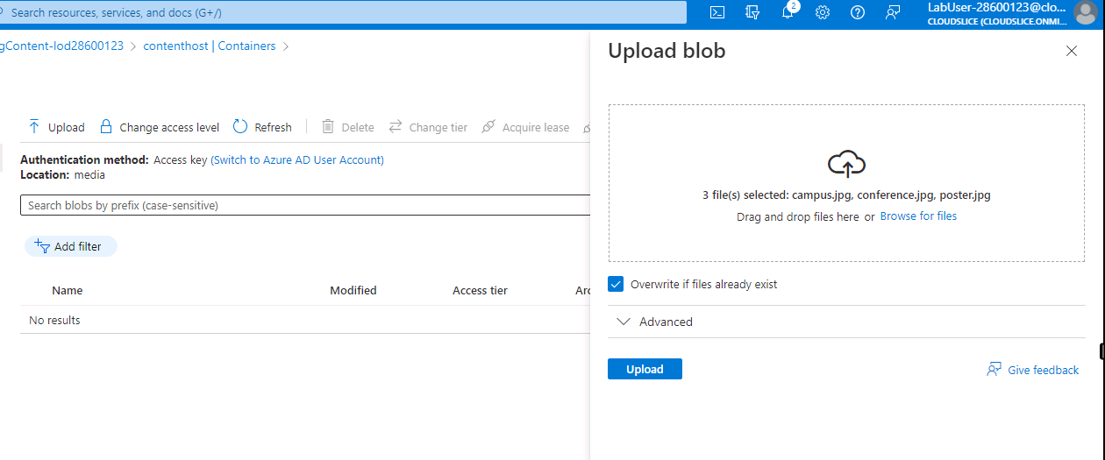

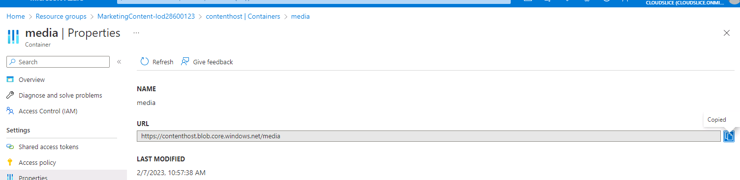

<https://contenthost.blob.core.windows.net/media>

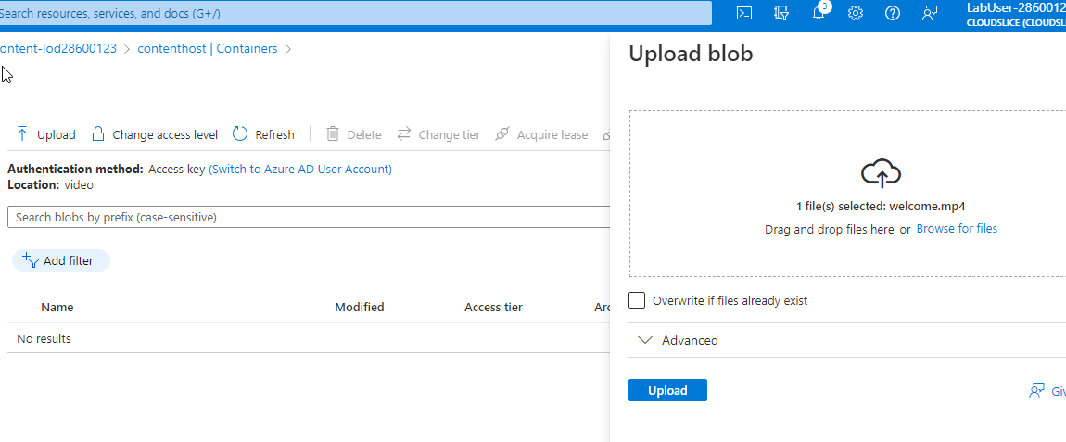

<https://contenthost.blob.core.windows.net/video> record uri

#### **Configure Web App settings**

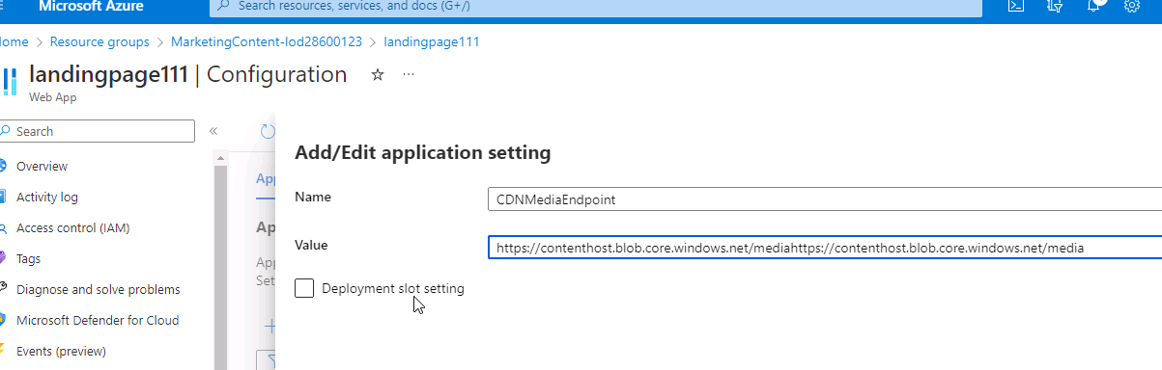

And for video endpoint

#### **Validate the corrected landing page**

Restart (or restarts on app settings change)



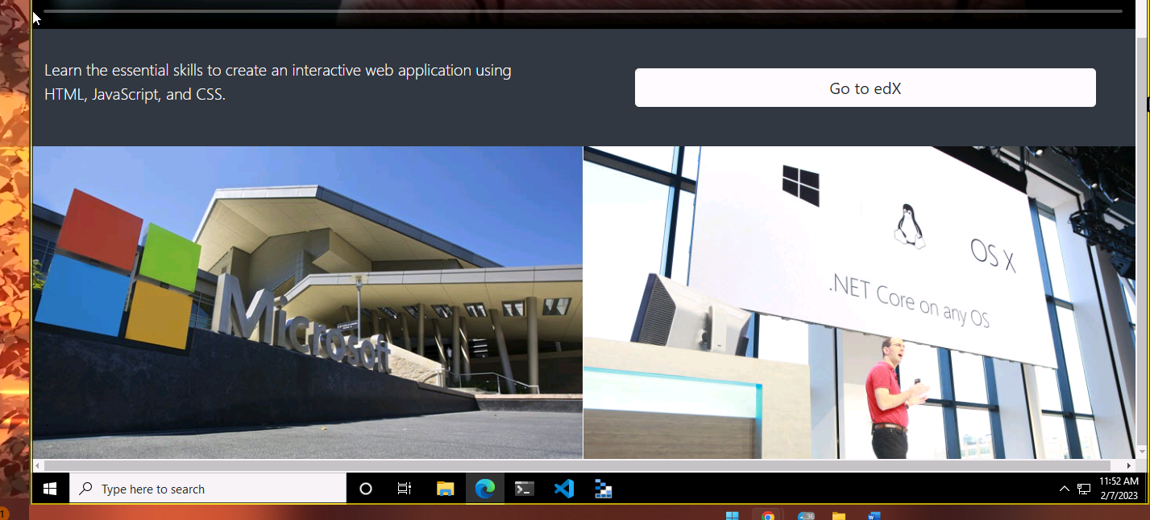

you uploaded multimedia content as blobs to Storage containers, and then updated your web app to point directly to the storage blobs.

### **Exercise 4: Use Content Delivery Network endpoints**

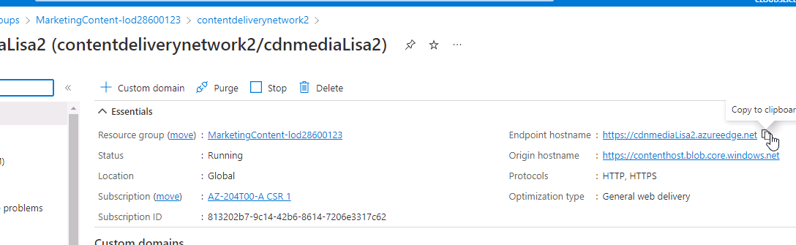

Endpoint hostname <https://cdnmediaLisa2.azureedge.net>

And for video <https://cdnvideoLisa.azureedge.net>

**Test multimedia content**

 If the content isn't available yet, the CDN endpoint is still initializing. This initialization process can take anywhere from 5 to 15 minutes.

#### 

#### **Update the Web App settings**

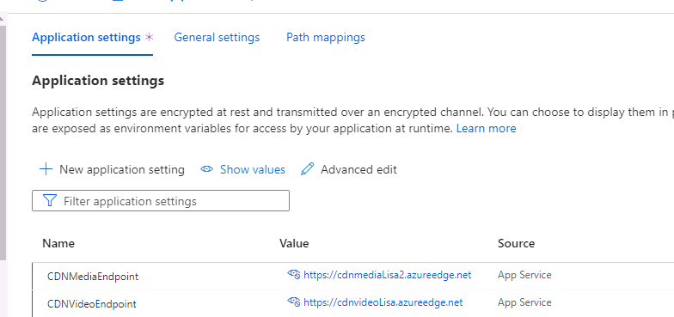

#### **Test the web content**

Web endpoint hostname

<https://cdnweb11.azureedge.net>

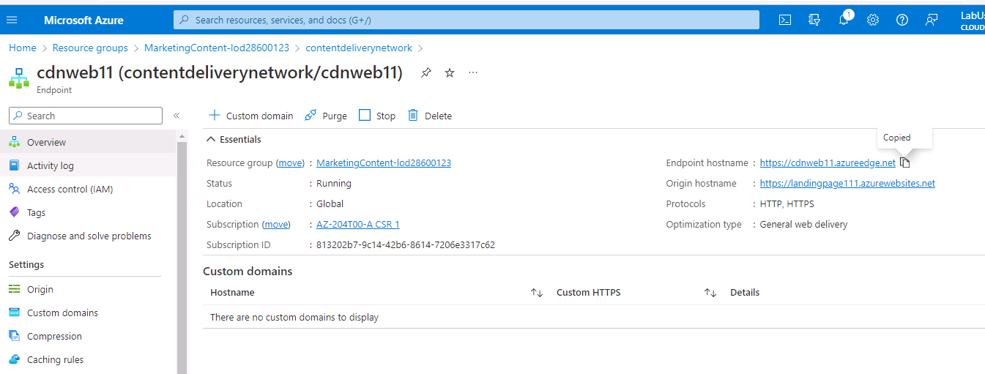

you updated your web app to use Content Delivery Network to serve multimedia content and to serve the web application itself.